

In partnership with
MONTHLY NEWSLETTTER February 2026
In the newsletter this month

 |  |  | 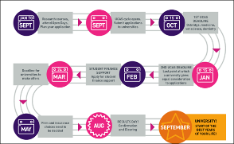 |  |  |  | 
Exploring Apprenticeships with the National Trust – Webinar for parents & carers: 25th February 2026 |  |  | 2027 cycle toolkit and webinar – Tuesday 10th March 12:30pm |  | Graduate Futures’ new barometer on careers support for students and graduates |  | AI training for all: government and industry programme expands - key AI skills by 2030 – Gov.uk
News updates

Government to invest £200m on SEND training package in England’s Schools and Colleges

 | The DfE has announced a £200m investment in SEND training and inclusion in England: £200 million landmark SEND teacher training programme - GOV.UK. The move recognises staff training is needed to ensure support for learners and avoid inconsistency, with every educator to have resources and flexible training; the Government will develop locally-adaptable materials, with input from educators. The DfE is exploring SEND as one of several CPD options for careers advisers in schools and colleges.
UCAS expands application fee-waiver scheme to care leavers
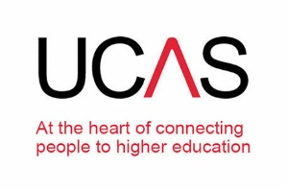 | Following the successful waiver of application fees in 2025 for students eligible for FSM, UCAS has announced the expansion of the scheme to include care leavers up to age 26 from this year: UCAS expands fee waiver to care leavers. As only 13% of care leavers go on to HE, compared to 46% for all other young people, the waiver hopes to encourage more care leavers to apply, recognising application fees are a barrier. Read the article in full here.
Economic growth hit by declining employer investment in training – Learning and Work Institute
 | The Learning and Work Institute has published a briefing paper: Economic growth hit by declining employer investment in training. Employer investment is now down 36% per employee since 2005 and fell 13% between 2022 and 2025. Since the apprenticeship levy was introduced, investment has fallen 23%, undermining the aims of the levy; with concern the impact is due to availability of cheaper online training or shorter options.

Graduate Futures’ new barometer on careers support for students and graduates
 | Graduate Futures institute (formerly AGCAS) has published its Quarterly Data Barometer report on careers and employability support. The report shows nearly a million students accessed careers information online, more than 215,000 attended 1:1 careers appointments and 386,000 attended careers events. 211,000 graduates also received careers support from their university and 45% of institutions offer lifetime careers support. The Barometer will track access each quarter, building a long-term view of trends.
WONKHE – NHS workforce plan must treat universities as partners
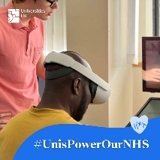 | This piece from WONKHE: The forthcoming NHS workforce plan must treat universities as partners discusses the new 10-year NHS workforce plan as an opportunity to consider the role of HE. With nearly double the number of doctors and nurses planned, its ambitious. Concerns remain that without clear funding and an implementation framework, and with universities and NHS trusts facing financial pressures, universities are being excluded from decisions shaping the future workforce. Read the full piece here.

Government response to Autism Report misses Careers in Schools
 | The Government have published their response to The Autism Act 2009 and new autism strategy report from the House of Lords. While this covered the Jobs and Careers Service, there was no mention of careers support in schools, while others are arguing for ‘dedicated SEND support focused on employability, including accessible careers advice, structured exposure to different pathways, and opportunities to build workplace skills in a supported way’ and ‘a new autism-specific programme of careers guidance for mainstream and specialist schools’. Read the Government response here.
QS rankings confirm UCL IOE as world-leading for Education for 12th year
 | For the twelfth-year running, UCL Institute of Education remains top in the world to study Education: QS rankings confirm IOE as world-leading for Education for 12th year | UCL Institute of Education. IOE has built a history of expertise in education and today is a leader in education research, knowledge exchange and training and professional development; while the UCL Bartlett Faculty of the Built Environment was number one for architecture and the built environment.
Guardian – The big AI job swap: why white-collar workers are ditching their careers
 | This 11th February article The big AI job swap: why white-collar workers are ditching their careers | The Guardian discusses concerns over the roles where AI may be starting to be utilised more regularly (such as content marketing, academic English editing and Health & Safety Policies and Procedure document writing) and the efforts white-collar workers are making to retrain in AI-proof career areas such as Counselling, Bakery and the Trades to combat this. Read the article here.

Upcoming Events

University of Cambridge – VIRTUAL events series for prospective students
 | The University of Cambridge and the colleges are running ‘virtual events for prospective students’: Upcoming events | Undergraduate Study. Including webinars ranging from and Cambridge for beginners 25th Feb, translation competitions on 27th February and Women in Computer Science on 1st March as well as many more. The events allow something for everyone. Students can register here.
Exploring apprenticeships with the National Trust: Parents & Carers - 25th February 6-7pm
 | Join the National Trust and Amazing Apprenticeships on Wed 25th February 6-7pm for this webinar designed for parents, carers and family members Exploring apprenticeships with the National Trust - Parents & Carers to discover the exciting apprenticeship opportunities opening with the National Trust in March 2026, ranging from project management, community work, business administration, information technology, marketing, human resources, gardening and more. Register here. The follow up webinar on 4th March 6-7pm is Applying for apprenticeships with the National Trust – Application support, which is for potential applicants who want to find out more about applying for an apprenticeship with the National Trust and feel confident and prepared for the recruitment process. Register here.
The Small Business Summer campaign
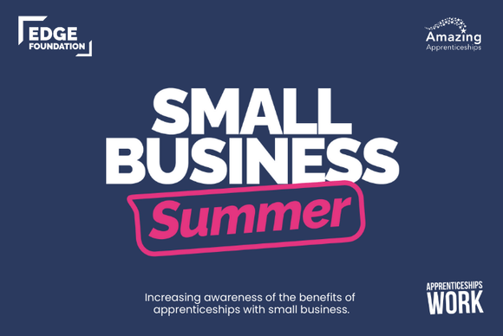 | Small Business Summer is a brand-new careers campaign from Amazing Apprenticeships, supported by the Edge Foundation. Designed to support young people in Years 7-13 to increase awareness of local small businesses, the benefits of being an apprentice in a smaller organisation and how to explore, search and apply for these roles. Find out more and get involved in this exciting campaign by joining the launch webinar on Thursday 26th February at 3:30-4:30pm.
Understanding T Levels: Industry Placement webinar – 2nd March 3:30-4:15pm
 | Aimed at Parents/Carers, Careers Leads and Teachers, Advisors and Heads of Year 11, this webinar from the DoE and Amazing Apprenticeships: Understanding T Levels: Industry Placement - Amazing Apprenticeships will cover the structure and content of an Industry Placement, how Placements are matched with the T Level student(s), how it works with the Training Provider and links to Curriculum, the benefits of learning through a T-Level and advice on preparing students for placement. Register here.
British Army Careers: Seven Career Streams webinar – Tuesday 3rd March 6:30-7:30pm
 | In celebration of National Careers Week 2nd to 7th March and International Women’s Day, this insightful webinar: British Army Careers: Seven Career Streams explores the range of opportunities in the British Army, with career streams including STEM, logistics, healthcare, engineering, intelligence, combat, and business-focused roles, this session showcases how young people can build rewarding, long-term careers, gain recognised qualifications and develop skills for life, whatever their interests, strengths or gender. Register here.
‘All things Law: Land your dream Apprenticeship in Law’ webinar – Thurs 5th March 6:30-7:30pm
 | Bringing together 3 apprentices to demystify the search and application process for Apprenticeships, this Success at School webinar: Land your dream Apprenticeship in Law for students in Year 11 to Year 13 aims to give application tips and strategies, tell the process how it really is and host a live Q & A. You can register here.
Save the Date: Cornwall Opportunities Skills & Careers Fair - Tuesday 10 March 2026 4-6pm
 | Join Cornwall Council at New County Hall, Truro, TR1 3AY on Tuesday 10th March 4-6pm for the Skills and Careers Fair. With Exhibitors and an Apprentices round table at 4pm and Employers roundtable at 5pm, the fair is an excellent way to build confidence in approaching employers and find out more about local training providers. Book your ticket at Cornwall Council Skills and Careers Fair | Eventbrite.
Oxford University –ONLINE Student Conference, 16th-19th March 2026
 | REMINDER: the University of Oxford’s 2026 Online Student Conference is taking place between 16-19th March 2026. A free online conference offering prospective students, teachers and supporters an opportunity to explore academic interests, engage with the Oxford community, and gain insights into studying at one of the world’s leading universities. Booking and event timetabling information will be released soon. Register your interest here.

Recommended Websites & Resources

University College London Podcasts – UCL MInds
 | University College London (UCL) offers a broad range of podcasts, accessible to all, to whet the appetite: Podcasts | UCL – University College London. With topics as diverse as Generation One: the Climate podcast, the Bartlett Faculty of the Built Environment Review, IOE insights, Brain Stories – UCL Neuroscience, there promises to be something for every student. View the range at Podcasts | UCL – University College London.
FutureSmart Careers February blog – Careers in Animal Care: What are your options?
 | The FutureSmart Careers February 2026 blog is now live on our website: Careers in Animal Care what are your options? Covering Required Skills, Gain relevant Education and Work Experience, some Typical Careers options, Careers you may not have considered and Useful links and Resources this is a great guide for students wanting to work with animals. Read the blog here.
UCAS – Visiting Conservatoire Open Days
 | For students considering studying at a UK Conservatoire from 2027 (Music, Composition, Drama, Theatre Studies, Performing Arts, Dance, etc.) Visiting Conservatoire Open Days | UCAS is a useful resource for Conservatoire Open Day dates all in one place and preparation ahead of events. Find out how a visit to LAMDA, Royal College of Music, Royal Welsh College of Music and Drama and Trinity Laban Conservatoire of Music and Dance among others can inform your decision here.
The Sixth Formers Guide to Degree Apprenticeships
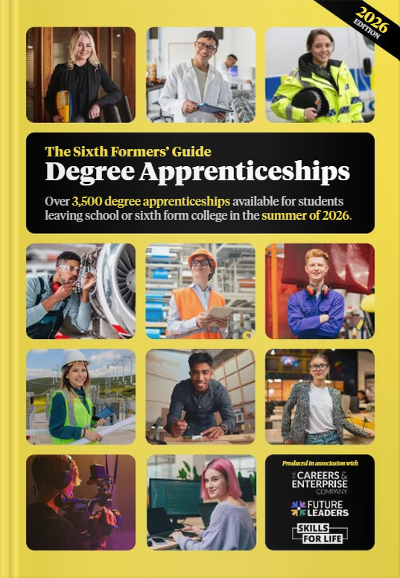 | REMINDER: Produced in association with the Careers and Enterprise Company, Future Leaders and Skills for life, this excellent guide covers 3,500 degree apprenticeships available to summer 2026 school and college leavers: The Sixth Formers' Guide to Degree Apprenticeships. With sections on earn as you learn, what is a degree apprenticeship, applying, employer profiles and an A-Z of Degree Apprenticeship employers, this is your go to for making informed decisions on Degree Apprenticeships. Access the guide here.
2027 cycle toolkit and webinar – Tuesday 10th March 12:30pm
 | Get ready for the 2027 cycle with your adviser toolkit. UCAS Adviser are kicking things off with a 2027 cycle toolkit and live support webinar on Tuesday 10th March at 12:30pm so you can join a panel of experienced advisers as we walk through what’s new. We’ll highlight key dates and share practical tips to help you confidently guide students from early discovery through to application. Register here.
Apprenticeship Opportunities

Cornwall Opportunities Bulletin – 6th February 2026
 | The Cornwall Opportunities Bulletin for 6th February 2026 includes opportunities such as: Light Vehicle Technician or Apprentice Recruitment Consultant in Truro, Trainee Smart Meter Technician in St Austell, Apprentice Early Years Educator in Devon and Rail Engineering Technician, Waste Acceptance Operative, Telecomms Higher Apprentice, Vessel Master Apprentice and Chef Apprentice in Plymouth among others. Access the bulletin here.
BAE Systems Degree Apprenticeships – 2026 applications open until end of February
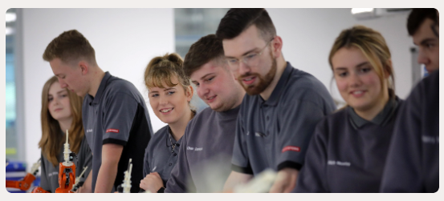 | Earn while you learn for a career where security comes first with BAE Systems. Aimed at school-leavers, the BAE Systems Degree Apprenticeship allows you to combine your studies with hands-on work and gain an honours degree, while paying a competitive salary. Their offer covers: Aerospace Engineering, Management, Nuclear Engineering, Project Management, Software Engineering, Information & Technology, and Enterprise Architecture. Apply now at BAE Systems careers.
Apprenticeships with Siemens – applications open
 | Apprenticeships at Siemens UK Want to build the future of tomorrow? A future that comes in all shapes and sizes, from everyday tech to robots and AI? If you have the ideas to lead progressive business and the passion to drive sustainability, you’re right where you need to be. Examples of roles are: Field Service Engineer Apprentice; Degree Apprentice - Software Design Engineer; Engineering Technician Apprenticeship - Level 3. Siemens are also offering VIRTUAL work experience: Explore your future with Siemens | Springpod.

Transport for London (TfL) Apprenticeships
 | Transport for London (TfL) are currently recruiting to the range of apprenticeships: Apprenticeship roles - Transport for London. Training options are available within the London Underground, Engineering, Technology and Business and roles are varied and range from Level 2 to Level 6 Degree Apprenticeship. Benefits are working for an innovative and sustainability-focused employer, diverse teams and networking opportunities and mental health and wellbeing support. Apply now at Apprenticeships - TfL.
Clifford Chance law firm – Access programme
 | ACCESS | Clifford Chance is an award-winning, two-year development programme for Year 12 (or equivalent) students. A founding member of PRIME Clifford Chance have developed ACCESS with accessible content, real legal sector insights, and opportunities to develop key skills, confidence, and commercial awareness. At the end of the ACCESS programme, we'll help you craft a strong application for our SPARK programme, which could ultimately lead to a Training Contract interview. Find out more and apply here.
Apprenticeships with AstraZeneca
 | With an AstraZeneca apprenticeship, you'll positively impact people's lives by helping discover, develop, and deliver life-changing medicines, building strong professional relationships with mentors, leaders and peers along the way. Options available to learn and grow include Level 6 Degree Apprenticeships across Biopharmaceuticals, Genomics Research & Development, Quality Control, Sustainability and Technology Solutions. Join AstraZeneca and shape the future of healthcare.
SHELL Apprenticeships – closing 28th February 2026
 | Shell are offering Level 6 Degree Apprenticeships in Leadership & Management and Digital & Technology: Apprenticeship Programme | Shell UK. Delivered by Corndel College London, on the Leadership programme you’ll learn how commercial operations run, build confidence, and grow your understanding of the energy industry, within the Downstream Renewables & Energy Solutions area; while Digital areas include: Software engineering, Data & analytics, Cyber Security, Digital product development and Cloud platforms & IT operations. Apply now.
For Careers Leaders/Heads of Careers Department
University of Cambridge: Teachers and Advisers webinar series returns for 2026
 | The University of Cambridge’s Teachers and Advisers' Webinar Series has returned for 2026, beginning with Introducing the Cambridge Application process on Wednesday 25th February 4:30-5:30pm. The webinar covers the timeline and different components of a student's application; as well as offering a Live Q & A session. View the events and book your place here.
Discovery Education Centre - Bristol
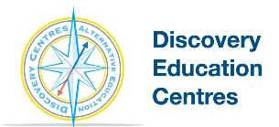 | Discovery Education Centre provides alternative education across primary and secondary centres in Bristol, supporting children and young people with a range of needs. Offering outdoor education and post-16 pathways in Construction and Hospitality, provision is built around learners, with 1:1 support, personalised ILPs, transport, food throughout the day, and course materials included. Working closely with schools, local authorities, and families to offer a supportive, structured environment that helps students re-engage with education and develop skills. Find out more here.
Best-practice Shout Out! – St Thomas the Apostle College
 | St Thomas and the Apostle College (a partner of FutureSmart Careers) featured in January’s NavigATE newsletter for their Beyond 18 Programme, a student-centred empowering careers programme. Find out about their student-led apprenticeship society where students meet, share best practice and invite alumni speakers, as well as their recent speed networking event with their Year 12s and 13s that included 150 alumni! Read the case study here.
Unifrog Teacher and Adviser Conference – 21st May and 4th June 2026
 | Join Unifrog in London 21st May or Birmingham 4th June for their Teacher and Advisor Conference. A free CPD event where you can learn from and network with fellow careers professionals and 40 employers and universities including: Aldi, Royal Horticultural Society (RHS), INTO Film, Chartered Institute of Banking (CIOB), the Met Police, Durham University, Bournemouth University, Liverpool John Moores and Warwick University. Register now as tickets are limited.
AI training for all: government and industry programme expands - key AI skills by 2030 – Gov.uk
Every adult in the UK is eligible to take FREE AI training for all, short courses to gain practical AI skills for work. Taking as little as under 20 minutes, the courses will give the skills needed to use simple AI tools effectively in the workplace and teach the use of AI for tasks like drafting text, creating content and completing admin tasks. Available now on the government’s AI Skills Hub.

Class Study in London (WCSiL) Conference 2026 – 18th to 19th June
 | Delivered by Imperial, King’s College London, The London School of Economics and Political Science (LSE) and University College London (UCL), the World Class Study in London (WCSiL) Conference for Teachers and Advisers will take place at Imperial on Thursday 18 June 2026, with optional campus tours of the participating institutions on Friday 19 June 2026. Places are limited to one teacher or adviser per school or college. Register your interest here by Sunday 8th March.
UCAS Adviser – Tips for supporting students after the January Equal Consideration Deadline
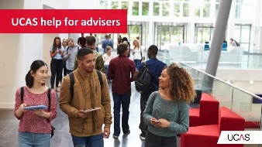 | If many of your students have now submitted their applications, they are probably feeling a mixture of relief, excitement, and sometimes uncertainty. As an adviser, your guidance is crucial in helping students stay informed, confident, and proactive. UCAS Adviser have put together some top tips to help: Top Tips for supporting students after they’ve submitted their application | UCAS. Covering options if they don’t receive offers, making application changes, regular tracking in the UCAS Hub and reassuring them there’s still time to apply until 30th June.
Get in touch
Helpline
 | Kyley Houghton, our Helpline Manager and our team welcome enquiries from schools, parents, and students. The helpline is staffed between 9.00 am and 5.00 pm Monday to Friday at helpline@futuresmartcareers.co.uk.
Contact us

Oliver Simper
Head of Careers
osimper@downside.co.uk

 | For all other enquiries, please contact our team at enquiries@futuresmartcareers.co.uk  or give us a call on Tel: 0330 311 9509  

No responsibility can be taken for the content of external websites mentioned in this newsletter
Registered FutureSmart Careers Limited Reg. No 11968993 (Registered in England & Wales). Registered office 14 Apex Court, Woodlands, Bristol, BS32 4JT

