

In partnership with
MONTHLY NEWSLETTTER December 2025
In the newsletter this month

 |  |  |  |  | 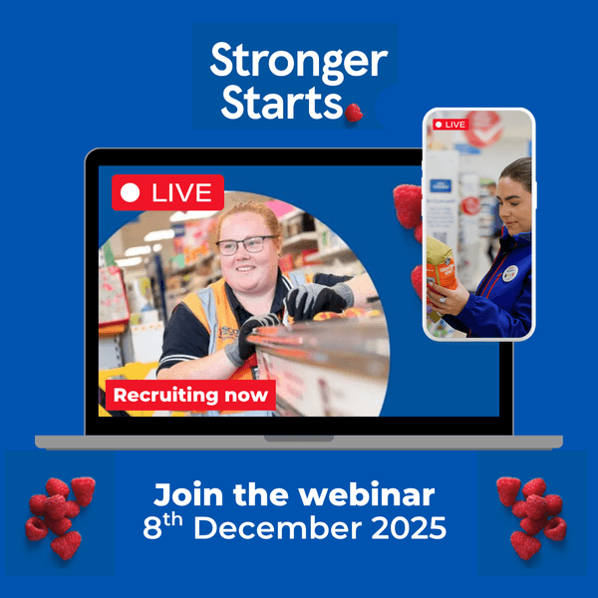 |  | 
Oxplore: Home of Big Questions - free monthly webinars for students aged 13-18 5-6pm |  |  | Autumn budget: £820m for Youth guarantee and free apprenticeships for SMEs |  | Tesco Stronger Starts Apprenticeship Programmes in Retail and Maintenance |  | Amazing Apprenticeships – SEND Hub for Careers Leaders, Teachers and Advisers
News updates

Autumn budget: £820m for Youth guarantee and free apprenticeships for SMEs
In the Autumn Budget, Chancellor Rachel Reeves announced £820m in funding for the Youth Guarantee, and the removal of the 5% top up for apprentices in small and medium businesses (SMEs). This means that SMEs won’t need to pay anything towards the training costs of apprentices under the age of 22. The £820m funding for the Youth Guarantee will go towards six months paid work placements for 18-to-21-year-olds on Universal Credit. Read more here.

Education Policy Institute report – ‘What you learn and what you earn’

 | The Education Policy Institute has published What you learn and what you earn: educational choices and labour market outcomes. Findings include: post-16 qualifications a key determinant of earnings by the age of 25, with level 3 qualification holders likely to earn considerably more than those without. Regardless of post-16 qualifications, disadvantaged students on average earn less than non-disadvantaged peers. A key driver of the gap is attainment at GCSE level, read the full report here.
Labour takes steps to bring higher education and local skills closer together

 | New Skills England guidance provides the detail for the white paper’s vision of a coherent skills system. In this interesting article Labour takes steps to bring higher education and local skills closer together, Michael Salmon assesses whether it could work, discussing Local Skills Improvement Plans (LSIPs), and the need for involvement from both the HE and the FE sector. Read the full article here.
Undertaking paid work while studying can lower HE outcomes – Student Working Lives

 | The recently published HEPI and University of Lancashire Student Working Lives report, has found that 66% of students work to cover living costs and 20% work to help pay tuition fees. Most work in low paid, flexible roles, 38% are on zero-hours or casual contracts and 43% state work makes stress, anxiety and depression worse, with better outcomes for those working less than 20 hours a week. Read the full report here, Executive Summary page 8 and 9.
WONKHE - Student finance changes in the budget
 | This article Student finance changes in the budget – director’s cut from the team at WONKE opines on the non-headline changes of grants, fees and loans, by presenting analysis of the changes for Care Leavers, those with dependents or in receipt of DSAs and Postgraduate thresholds (for those considering Master or PhD study, as well as Undergraduate), raising some interesting points for those considering HE versus an Apprenticeship, Degree Apprenticeship or Employment at 18+. Read more here.

Upcoming Events

BIMM Music Institute’s Open days event – Saturday 6th December
 | Upcoming event: BIMM Music Institute is holding Open days at many of their campuses this Saturday, 6th December. With in-person events at Birmingham, Bristol, Brighton, Dublin and London that day, a Virtual Open Evening on Tuesday 9th December 6-8pm and January 2026 open events at Manchester and Berlin and the UK Music industry booming, there be should be something for those wishing to study near home, live away or who can’t attend in-person this month.
Accountancy Apprenticeship Application Masterclass with ACCA – 9th December 6:30-7:30pm
 | Hosted by ACCA, the world’s leading accountancy body, this interactive Accountancy Apprenticeship Application Masterclass workshop is your step-by-step guide to acing the apprenticeship application process and standing out while doing it. Gain insider tips on how to impress during interviews and at assessment centres, put yourself ahead of the competition and learn what a strong application looks like. Speakers are Ria Bush (HM Treasury) and George Tsounias (ACCA Global). Register here.
UCL Arts & Humanities application Q & A – 11th December, 4 – 5pm
 | Are your students interested in an Arts and Humanities degree? UCL Arts & Humanities is recognised globally for both its teaching and research excellence, from Fine Art to Modern Languages. They have an online information session on 11 December 2025, 4-5pm, learn about interdisciplinary degrees and ask the Admissions team about applications to Arts & Humanities courses. Suitable for prospective students, teachers, advisers and counsellors, book here.
The Tech Mentor VIRTUAL No-Code Hackathon - Saturday, 13th December, 10am - 4pm
 | Tech Mentor’s next VIRTUAL No-code Hackathon is on Saturday 13th December from 10am-4pm. Aimed at 14–18s to help them explore the world of tech and with opportunities ranging from app development and game design to cybersecurity and sustainable energy, students can develop their passion and gain valuable skills. Participants receive certificates, winners advance to nationals and compete for cash prizes. With National Finals 11th July and registration £15, students can register here.
Oxplore: Home of Big Questions - free monthly webinars for students aged 13-18 5-6pm
REMINDER: Oxplore is a free webinar series for 13–18s. Each session explores a question, encouraging critical thinking and discussion. Parents, carers and teachers welcome and a post- session challenge for students ‘Letters to the Editor’, selected entries receive a book token and certificate for their school. With “Does art have to be beautiful?” on Fri 12th December and “Can we believe the history books?” on Wed 17th December, explore the events and register here.

UK University and Apprenticeship Search Fairs – spring/summer 2026
 | A fantastic opportunity for students in Years 12 & 13 considering their future career and education pathways, the UK University and Apprenticeship Search Fairs of spring/summer 2026 will be attended by Russell Group, red brick and modern institutions, as well as Apprenticeship providers. With events in Surrey, Bristol, Brighton and London during spring term, its worth a visit. Register a group here.
Recommended Websites & Resources

Amazing Apprenticeships - Resources to support students applying for Apprenticeships
 | It's that time of year when students are thinking about next steps, and for those who are considering an apprenticeship - getting ready to apply! Amazing Apprenticeships has a wide range of resources to help students on their journey, including the Meet the Employer vacancy search tool, a 'How to Apply' Guide, the 'Get ready to Apply' Checklist to help students to feel ‘application ready’, and more. Discover resources to support your student here.
Medicine interviews - everything you need to know
 | If you’re applying for 2026 entry Medicine, you could be invited to Medicine interviews very soon. The Medic Portal has a guide to when Med Schools are likely to send out their invites, plus whether they’re doing MMIs or panel interviews, so you can plan your interview prep – see the guide here. Don’t forget to revisit the FutureSmart Careers blog Medicine interviews - everything you need to know too.
Inspiring the next generation of health and safety professionals – Success at School Careers pack
 | Inspire young people to choose a career in health and safety. Success at School have put together a handy Careers Pack to give students an insight into: What a health and safety career involves, Know if a career in health and safety is for you, How to get started and Stories from young health and safety professionals. With a dedicated Apprenticeships page, students can find Apprenticeships with a NEBOSH qualification here.
Gatsby Benchmark 4 and the statutory duty: Why curriculum is now careers territory
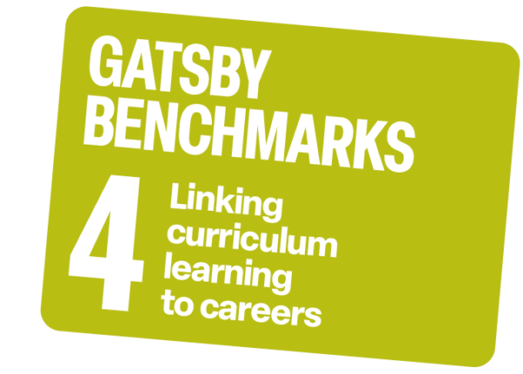 | Linking curriculum learning to careers is now a statutory requirement, making it every teacher’s responsibility to help students understand how their subjects connect to future pathways. In this useful guide from UCAS Adviser news: Gatsby Benchmark 4 and the new statutory duty, Careers specialist Caroline Green explains what this means in practice, and how schools can embed meaningful career connections across the curriculum.
FutureSmart Careers December blog – From Vision to Venue, your Guide to Event Planning Careers
 | The FutureSmart Careers December 2025 blog is now live on our website: From Vision to Venue Your Guide to Event Planning Careers. Covering aspects such as: What does an Event Planner do, Roles in Event Planning, Related Careers, Skills and Qualifications needed, How to Get Started and Useful Links, this is a guide to Event Planning Careers. Read the blog here.
Apprenticeship Opportunities

Tesco Stronger Starts Apprenticeship Programmes in Retail and Maintenance
 | The Tesco Stronger Starts Apprenticeship programmes in Retail and Maintenance will open for application again soon. Apprentices gain hands-on experience, nationally recognised qualifications and genuine support every step of the way, with flexible options and clear routes for progression. Join Amazing Apprenticeships and the Tesco Early Careers team on 8th December at 4pm to learn about the Stronger Starts apprenticeships available, what is involved and more. Register here to attend or receive the recording.
Space Systems Engineering Degree Apprenticeship Babcock – deadline to apply: 18th December
 | REMINDER: This Space Systems Engineering Degree Apprenticeship | Babcock offers a BEng in Space Systems Engineering from the University of Portsmouth. The global industry is expected to triple in value by 2035, this is your chance to gain in-demand skills and shape the UK’s future in space. Apprentices work 4 days a week at either Hawthorn (Corsham) or Oakhanger (Bordon), studying one day a week. Find out more and apply here.
Channel 4 Careers: Apprenticeships now open – deadline 2nd January 2026
 | Channel 4 offers a range of apprenticeships based around the UK including Bristol, Glasgow, Manchester, Leeds and London: Apprenticeships | Channel 4. Apprentices are based in one department for 14-36 months, and can study at Level 2, 3, 4 or 6, learning all about their department and have the chance to be part of a range of in-depth projects. The deadline to apply is 2nd January and available Apprenticeships can be found here.

Slaughter and May Apprenticeship programme – applications are open, deadline 7th January
 | Applications are open for the Slaughter and May Solicitor Apprenticeship Programme, which starts in September 2026 and runs for 6 years. To be eligible you must have achieved 7 GCSEs at grade 6 or above, including Maths and English and have achieved or be predicted to achieve AAB at A Level. Please note that interviews will take place between 16 March and 9 April 2026. Find out more and apply by 7th January here.
Cornwall Opportunities Bulletin – December 2025 edition


Cornwall Council’s - Economy and Skills Service’s Apprenticeships vacancy list the Cornwall Opportunities Bulletin 05122025. This is the 5th of December 2025 version and there is a good mix of Level 2 and Level 3 options and unusual opportunities such as a Family Barrister’s Clerk apprenticeship in Plymouth and a Horticulture apprenticeship in Cornwall, as well as more typical opportunities such as Hairdressing or Business. For more information about when the bulletin will be published and how young people can apply, contact Cornwall Council’s Employment and Apprenticeship team.

Morgan Stanley Technology Professional Degree Apprenticeship (London) – apply by 8th Feb 2026
 | Morgan Stanley’s Technology Professional Degree Apprenticeship Program, during which you will study at Queen Mary University, London and rotate into different areas of the Technology Division, is four years long and combines on-the-job training alongside a part time degree; great for School Leavers looking for a technology-focused career. Entry requirements include: Maths GCSE at B or above and A Level grades AAB or ABB including Computer Science or Mathematics. Read more and apply here.
John Lewis Partnership – Buying and Merchandising Apprenticeships
 | John Lewis offer Buying & Merchandising apprenticeship programmes, in collaboration with EFI Training: Buying and Merchandising Apprenticeships. Offered at Level 4 the Buying and Merchandising Assistant apprenticeship can lead to a Level 6 qualification and the off-the job training is offered at the Fashion Retail Academy campus in Central London. Students can register their interest here.

For Careers Leaders/Heads of Careers Department
CDPG event in House of Lords highlights career development opportunities – 25th November
 | Part of the CDPG’s ongoing work to raise the profile of career development in policy decision-making, the Career Development Policy Group (CDPG) sponsored an event in House of Lords exploring the challenges in empowering young people through careers guidance, the role of career development in addressing NEETs, work experience approaches, ensuring schools have sufficient levels of staffing in Careers roles and the role of careers guidance higher education. Read more here.

CDI publishes Young Lives, Young Futures report – 29th November 2025
 | The Young Lives, Young Futures report looking at EET opportunities for young people in England who don’t go to university: Young people face uneven quality and availability of careers guidance shows school can feel like a ‘hostile’ environment for many, the impact of Covid on post-16 transitions and barriers to non-university routes. The report also states many young people lack access to impartial advice from professionally qualified careers advisers. Read more here.
UCAS Adviser Live webinar – Guiding late applicants: Strategies for success, 12:30pm 7th Jan
 | Supporting your students with last-minute university applications can be challenging. This UCAS Adviser live webinar is designed to help you feel prepared and confident when guiding late applicants. We’ll share practical strategies to manage tight timelines, help students make informed choices quickly, complete personal statements and write their references; we’ll cover the essentials – with time for questions throughout. Register here.
UCAS Adviser - Build your confidence in guiding students through UCAS
 | Aimed at new advisers, staff from newly registered centres and staff new to supporting UCAS applicants, Adviser Fundamentals covers everything you need to know: Step into the student experience – UCAS Hub and application journey from student’s perspective; Expert guidance – your questions answered and learn how to navigate UCAS systems; Best practice – professional and peer support to refine your approach. £30+ VAT, contact the Schools and Colleges Success team at training@ucas.ac.uk.

Amazing Apprenticeships – SEND Hub for Careers Leaders, Teachers and Advisers
Amazing Apprenticeships has a SEND Hub zone focussed on providing information and inspiration in a variety of accessible ways The resources have been created with the SEND Advisory Network – a collaboration of more than 100 careers professionals throughout England. Discover rapid reads on functional skills qualifications, how to find inclusive employers, image-led guides on apprenticeship essentials, interactive puzzle and activity sheets and case study films. Access the resources here.

Get in touch

FutureSmart Essentials for schools (PDF)

FutureSmart Careers offers a range of well-loved packages for schools but can also tailor a plan to fit schools’ needs exactly. Our FutureSmart Essentials package includes:

  - Suite of downloadable resources
  - 9-5 careers advice helpline
  - Monthly newsletters with news, events and opportunities

Many schools upgrade to FutureSmart Pro which includes all of the benefits of Essentials plus additional in-school support from our team of qualified advisers for workshops, personal guidance sessions, talks and other activities tailored to the schools’ exact requirements.

Helpline
 | Kyley Houghton, our Helpline Manager and our team welcome enquiries from schools, parents, and students. The helpline is staffed between 9.00 am and 5.00 pm Monday to Friday at helpline@futuresmartcareers.co.uk.
FutureSmart Careers Apprenticeship Support
 | FSC now offers an Apprenticeship Support Package to schools and colleges. We have produced a suite of workshops and talks to include the best bits from the ASK programme, but with the added extras we feel are needed. The Apprenticeship support we are offering is a paid for service, but we are working hard to make it cost effective and flexible to help you support your students. We are also able to work in all geographic areas we cover.  If you would like to find out more about this service or book in a meeting to discuss further, please click on the link to complete the form: Apprenticeship Support - Expression of Interest Form

Contact us
 | For all other enquiries, please contact our team at enquiries@futuresmartcareers.co.uk  or give us a call on Tel: 0330 311 9509  Wishing you all a happy, healthy and restful Christmas.  Oliver Simper  Head of Careers  osimper@downside.co.uk  
No responsibility can be taken for the content of external websites mentioned in this newsletter
Registered FutureSmart Careers Limited Reg. No 11968993

